Controlled Terminology

📘 What is Controlled Terminology
# Source: AI Source: Provided by: [Data Path: Persons Table -> ID Column: 1, Name_En Column: Motasem Essam] -> From: [Chatgpt (GPT-4-turbo)] on [7/31/2025]
Controlled Terminology refers to a predefined, standardized set of terms used consistently within a field to ensure clarity, accuracy, and uniformity, especially in technical, scientific, or regulated environments.

🔍 Definition:
# Source: AI Source: Provided by: [Data Path: Persons Table -> ID Column: 1, Name_En Column: Motasem Essam] -> From: [Chatgpt (GPT-4-turbo)] on [7/31/2025]
Controlled Terminology is a curated and restricted vocabulary where terms are selected, defined, and maintained to avoid ambiguity and variation in language use.

🧠 Key Features:
# Source: AI Source: Provided by: [Data Path: Persons Table -> ID Column: 1, Name_En Column: Motasem Essam] -> From: [Chatgpt (GPT-4-turbo)] on [7/31/2025]
- Standardized definitions approved by an authority or organization
- Used consistently across systems, documents, or databases
- Helps in data sharing, retrieval, and analysis
- Often part of ontologies, taxonomies, or thesauri
- Common in medicine, pharmacology, AI, legal, and technical documentation

🧪 Examples:
# Source: AI Source: Provided by: [Data Path: Persons Table -> ID Column: 1, Name_En Column: Motasem Essam] -> From: [Chatgpt (GPT-4-turbo)] on [7/31/2025]
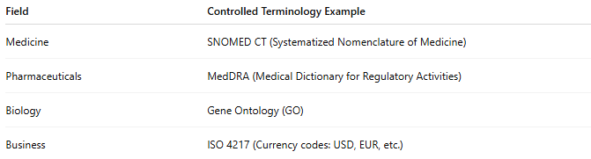
Field | Controlled Terminology Example
Medicine | SNOMED CT (Systematized Nomenclature of Medicine)
Pharmaceuticals | MedDRA (Medical Dictionary for Regulatory Activities)
Biology | Gene Ontology (GO)
Business | ISO 4217 (Currency codes: USD, EUR, etc.)

👥 Primary Users:
# Source: AI Source: Provided by: [Data Path: Persons Table -> ID Column: 1, Name_En Column: Motasem Essam] -> From: [Chatgpt (GPT-4-turbo)] on [7/31/2025]
- Researchers
- Data analysts
- Regulatory agencies
- Software developers (especially in AI, databases)
- Technical writers

Specialized terminology vs Field-Specific Terminology vs Controlled Terminology

🔍 Comparison Table
# Source: AI Source: Provided by: [Data Path: Persons Table -> ID Column: 1, Name_En Column: Motasem Essam] -> From: [Chatgpt (GPT-4-turbo)] on [7/31/2025]
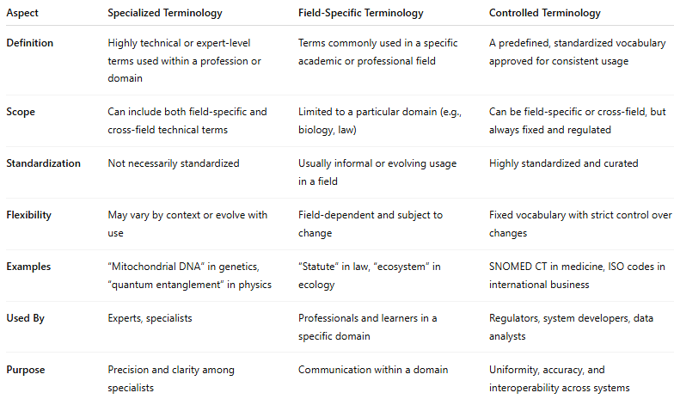
Aspect | Specialized Terminology | Field-Specific Terminology | Controlled Terminology
Definition | Highly technical or expert-level terms used within a profession or domain | Terms commonly used in a specific academic or professional field | A predefined, standardized vocabulary approved for consistent usage
Scope | Can include both field-specific and cross-field technical terms | Limited to a particular domain (e.g., biology, law) | Can be field-specific or cross-field, but always fixed and regulated
Standardization | Not necessarily standardized | Usually informal or evolving usage in a field | Highly standardized and curated
Flexibility | May vary by context or evolve with use | Field-dependent and subject to change | Fixed vocabulary with strict control over changes
Examples | “Mitochondrial DNA” in genetics, “quantum entanglement” in physics | “Statute” in law, “ecosystem” in ecology | SNOMED CT in medicine, ISO codes in international business
Used By | Experts, specialists | Professionals and learners in a specific domain | Regulators, system developers, data analysts
Purpose | Precision and clarity among specialists | Communication within a domain | Uniformity, accuracy, and interoperability across systems

🔑 Summary:
# Source: AI Source: Provided by: [Data Path: Persons Table -> ID Column: 1, Name_En Column: Motasem Essam] -> From: [Chatgpt (GPT-4-turbo)] on [7/31/2025]
- Specialized Terminology = Technical language used by experts.
- Field-Specific Terminology = Everyday professional language within a domain.
- Controlled Terminology = Officially approved list of terms used consistently, especially in data-heavy or regulated contexts.

